Please refer to the Terms & Conditions of Friends membership
(www.fulhampalace.org/support-us/friends) before completing this form.

Name(s) …………………………………………………………………………………………………………………………………….
Address ……………………………………………………………………………………………………………………………….…….
……………………………………………………………………………… Postcode …………………………………….
Tel ……………………………………………………... (Home) …………………………………………………. (Mobile)
Email (Lead member) ………………………………………………………………………………………………………………………..
Email (2nd member) ……………………………………………………………………………………………………………..

I wish to support Fulham Palace by becoming a Friend / renewing my membership (please circle)

Select membership:

Individual £25 per annum ( )
Joint (2 adults at the same address) £40 per annum ( )
Family (2 adults and up to 4 children under 18) £50 per annum ( )

I would like to make an additional donation of £……………….. Total Payable £………………….
Gift Aid can only be claimed on your donation. To claim Gift Aid you must complete the declaration below.

( ) I/We enclose a cheque for £…………………… made payable to ‘The Friends of Fulham Palace’
( ) I/We will/have set up a direct debit via PayPal/Standing Order (please circle)
If you would like to set up a standing order please complete the reverse of this form.

Boost your donation by 25p of Gift Aid for every £1 you donate
In order to Gift Aid your donation, you must tick the box below.

( ) Please treat as Gift Aid donations all qualifying gifts of money made to The Friends of Fulham Palace (registered
charity number 277797) today, in the past 4 years, and in the future.

I confirm that I am a UK taxpayer and understand that if I pay less Income Tax and/or Capital Gains Tax than the amount of Gift Aid claimed on all my donations in that tax year it is my responsibility to pay any difference. I understand that my membership fee is not eligible for Gift Aid.

Signature ............................................................................................... Date............................................................
Please remember to notify us if your contact details or circumstances change.

Thank you for supporting The Friends of Fulham Palace. The details you supply will be used for administering your membership, claiming Gift Aid if applicable and other purposes as detailed in the Terms & Conditions of your Friends membership. You can opt out of communications at any time.

Your personal data is safe with us; we will not share it with any third parties other than with Fulham Palace Trust and our ticketing and membership partners for the purpose of delivering your membership. Your details will never be sold or swapped with any third party. Full details of how we look after our supporters’ data are available in our Privacy Notice on our website at www.fulhampalace.org/support-us/friends.

Please sign and return this form to The Friends of Fulham Palace, Development Office, Fulham Palace, Bishop’s Avenue, London SW6 6EA, or email it to friends@fulhampalace.org.

I/we have read the Terms & Conditions of my/our membership with Fulham Palace as detailed on the website www.fulhampalace.org/support-us/friends and I/we will be happy to proceed with the membership contract.

Signature (Lead member) ……………………………................................................. Date …………………………………
Signature (2nd member)..…………………………...................................................... Date …………………………………

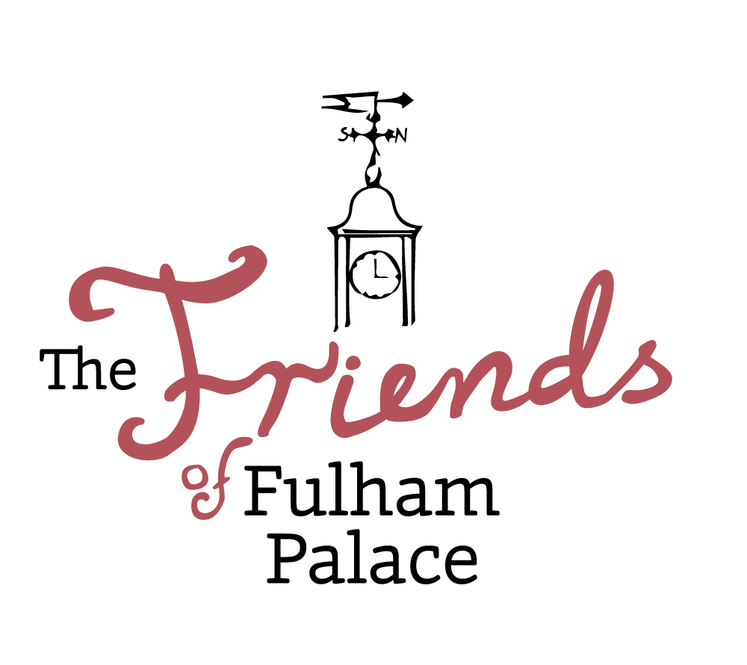

The Friends of Fulham Palace
Standing Order Form

Instructions to your bank to pay by Standing Order:

Name of Bank/Building Society:
Address of Bank:
Postcode:

Please pay to the account of The Friends of Fulham Palace:
HSBC, 593-599 Fulham Road, London SW6 5UA.
Sort Code 40-03-09, Account Number 61737813 to the sum of:

£ on the day of (month) (year)

and continue to make the same payment MONTHLY ANNUALLY until further notice
(please circle).

(NB: the date of the first payment should be at least one month from today’s date.)

Your Account Number

Sort Code

My payment is made up of:
( ) Individual membership £25 ( ) Joint membership £40 ( ) Family membership £50
( ) Donation £ ……………………..

Name:
Address:
Postcode:
Signature:
Date:

NOTE TO PAYING BANK: PLEASE QUOTE REFERENCE:

Please return this form to:
Development Office, The Friends of Fulham Palace, Fulham Palace, Bishop’s Avenue, Fulham, London, SW6 6EA
Tel: 020 7751 2437 Email: friends@fulhampalace.org

Registered Charity No: 277797

