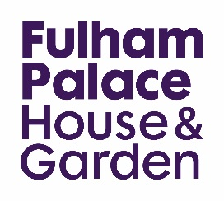

Schools booking form

To make a booking please complete and return this form to education@fulhampalace.org.
We welcome any pre-visits or phone calls to discuss your needs. If you have any questions please contact Jean Shipton, education officer on +44(0)20 7751 2432.
Teacher’s name
Contact’s name (if different)
School
School address

Borough
e.g. London Borough of Hammersmith and Fulham
Tel | Email
Session requested
Requested date(s)
Preferred time
All sessions last for 1½ hours. Unless otherwise indicated, morning sessions start at 10.00, and afternoon sessions at 13.00.
Year group
Number of pupils
Sessions can accommodate up to 30 pupils
Number of adults
At least minimum government staffing ratios are required
and higher ratios for children with specific needs.
Do you require a lunchroom? Delete as appropriate Yes / No
We have a large lawn which is the ideal spot for picnics, but our classrooms can be booked in case it is a rainy day.

Please use the section below to let us know if any pupils have special educational needs, allergies, or mobility requirements.

Sessions cost £115. The invoice must be paid in full within two weeks of receiving the invoice. Cancellations on the day will incur the full fee. Cancellations within two weeks of the visit will incur a 50% charge. Limited bursary places are available for school visits.
Please contact us for more information: education@fulhampalace.org

